Ideation Phase
Brainstorm & Idea Prioritization Template

Date | 04 July 2026
Team ID
Project Name | Personalised Networking Assistant
Maximum Marks | 4 Marks

Brainstorm & Idea Prioritization Template:
Brainstorming played an important role in the development of the Personalized Networking Assistant project. Our team discussed various ideas to solve challenges faced by people during networking events, seminars, and conferences. Every member contributed suggestions and possible solutions.
The ideas were evaluated based on user benefit, feasibility, and implementation effort. After prioritizing the most useful features, we selected an AI-powered assistant that analyzes event details, generates conversation topics, provides fact-checked information, and stores conversation history.
This process helped the team identify the best solution and develop a practical application using Streamlit, FastAPI, and KeyBERT with DistilBERT technologies.
Reference: https://www.mural.co/templates/brainstorm-and-idea-prioritization
Step-1: Team Gathering, Collaboration and Select the Problem Statement

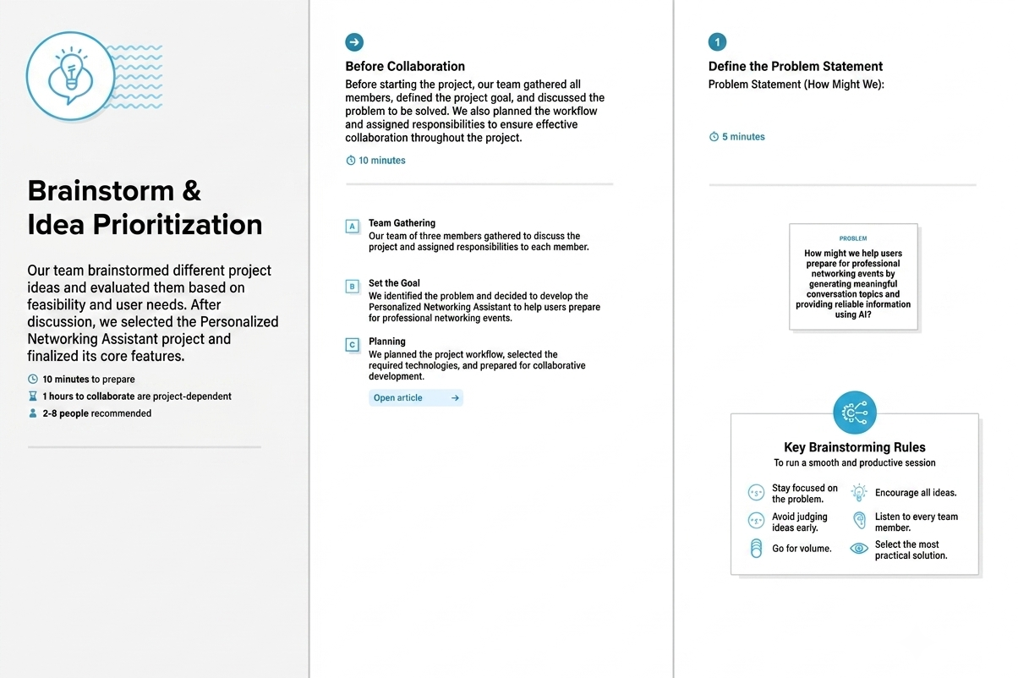

Step-2: Brainstorm, Idea Listing and Grouping
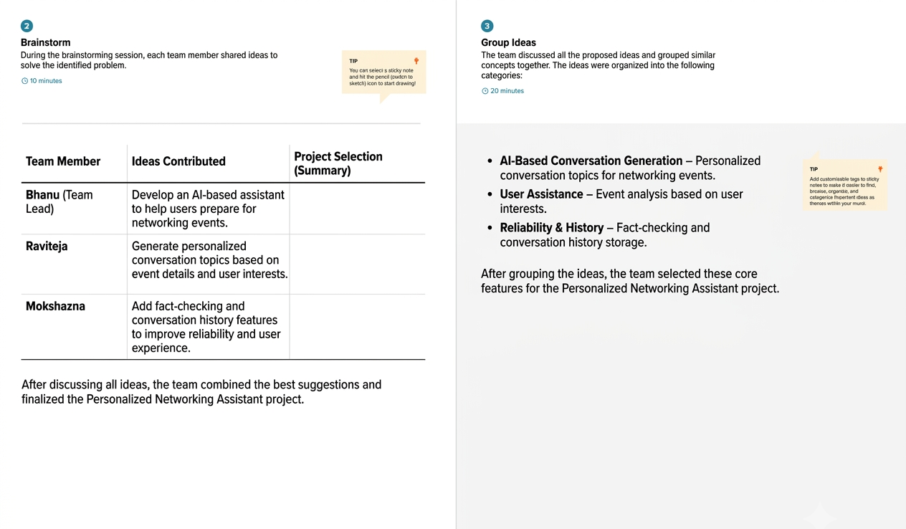

Step-3: Idea Prioritization
